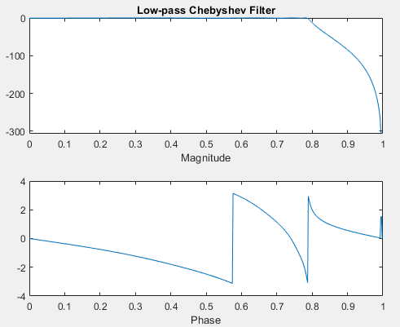
Q1(A)
% Low-pass Chebyshev Filter
wp = 0.125*2*pi;
ws = 0.1375*2*pi;
Rp = 0.5;
As = 20;
n = 8;

[b, a] = cheby1(n, Rp, wp, 'low');
[H, w] = freqz(b, a);

subplot(2,1,1);
plot(w/pi, 20*log10(abs(H)));
title('Low-pass Chebyshev Filter');
xlabel('Magnitude');

subplot(2,1,2);
plot(w/pi, angle(H));
xlabel('Phase');

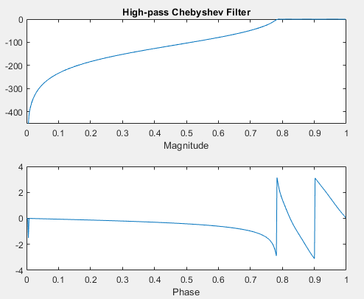
Q1(B)
% High-pass Chebyshev Filter
wp = 0.125*2*pi;
ws = 0.1375*2*pi;
Rp = 0.5;
As = 20;
n = 8;

[b, a] = cheby1(n, Rp, wp, 'high');
[H, w] = freqz(b, a);

subplot(2,1,1);
plot(w/pi, 20*log10(abs(H)));
title('High-pass Chebyshev Filter');
xlabel('Magnitude');

subplot(2,1,2);
plot(w/pi, angle(H));
xlabel('Phase');

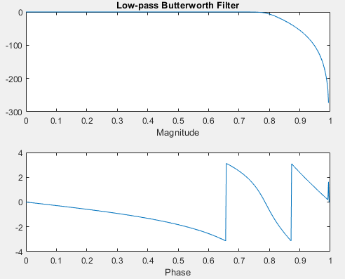
Q2(A)
% Low-pass Butterworth Filter
wp = 0.125*2*pi;
ws = 0.1375*2*pi;
Rp = 0.5;
As = 20;
n = 8;

[b, a] = butter(n, wp, 'low');
[H, w] = freqz(b, a);

subplot(2,1,1);
plot(w/pi, 20*log10(abs(H)));
title('Low-pass Butterworth Filter');
xlabel('Magnitude');

subplot(2,1,2);
plot(w/pi, angle(H));
xlabel('Phase');

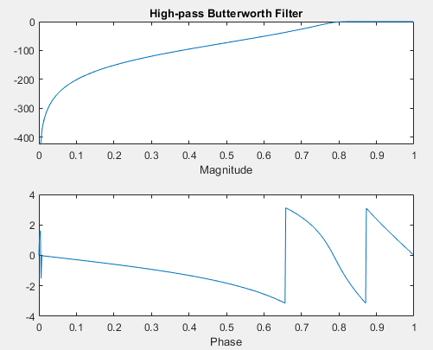
Q2(B)
% High-pass Butterworth Filter
wp = 0.125*2*pi;
ws = 0.1375*2*pi;
Rp = 0.5;
As = 20;
n = 8;

[b, a] = butter(n, wp, 'high');
[H, w] = freqz(b, a);

subplot(2,1,1);
plot(w/pi, 20*log10(abs(H)));
title('High-pass Butterworth Filter');
xlabel('Magnitude');

subplot(2,1,2);
plot(w/pi, angle(H));
xlabel('Phase');

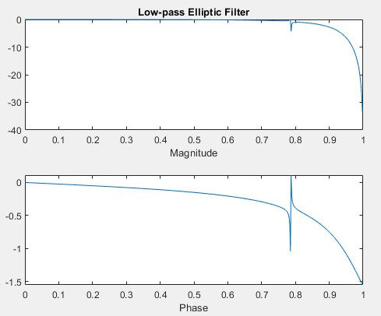
Q3(A)
% Low-pass Elliptic Filter
wp = 0.125*2*pi;
ws = 0.1375*2*pi;
Rp = 0.5;
As = 20;
n = 5;

[b, a] = ellip(n, Rp,1.0, wp, 'low');
[H, w] = freqz(b, a);

subplot(2,1,1);
plot(w/pi, 20*log10(abs(H)));
title('Low-pass Elliptic Filter');
xlabel('Magnitude');

subplot(2,1,2);
plot(w/pi, angle(H));
xlabel('Phase');

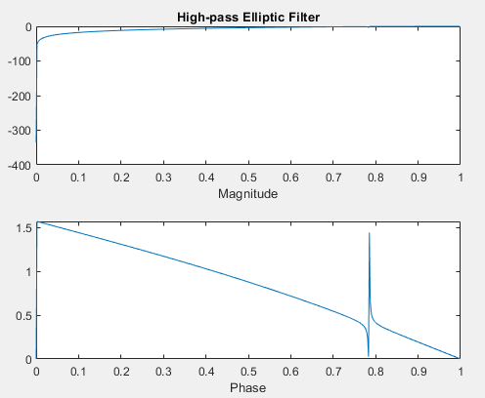
Q3(B)
% High-pass Elliptic Filter
wp = 0.125*2*pi;
ws = 0.1375*2*pi;
Rp = 0.5;
As = 20;
n = 5;

[b, a] = ellip(n, Rp,1.0, wp, 'high');
[H, w] = freqz(b, a);

subplot(2,1,1);
plot(w/pi, 20*log10(abs(H)));
title('High-pass Elliptic Filter');
xlabel('Magnitude');

subplot(2,1,2);
plot(w/pi, angle(H));
xlabel('Phase');

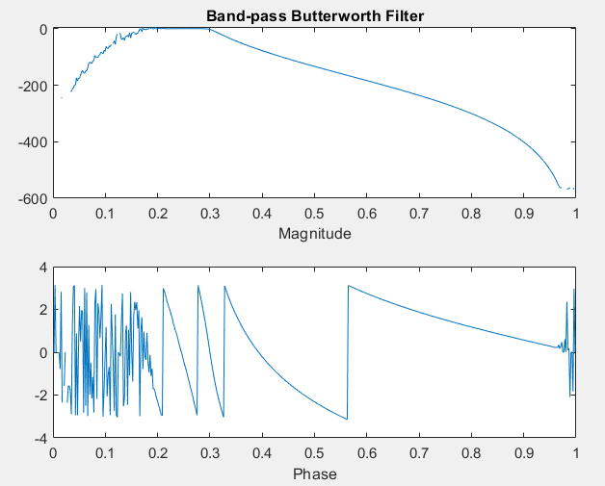
Post Lab
% Band-pass Butterworth Filter
ws = 2000;
w1 = 100;
w2 = 300;
order = 32;

wn = [w1 w2] / (ws / 2);

[b, a] = butter(order/2, wn, 'bandpass');
[H, w] = freqz(b, a);

subplot(2,1,1);
plot(w/pi, 20*log10(abs(H)));
title('Band-pass Butterworth Filter');
xlabel('Magnitude');

subplot(2,1,2);
plot(w/pi, angle(H));
xlabel('Phase');

